1: | 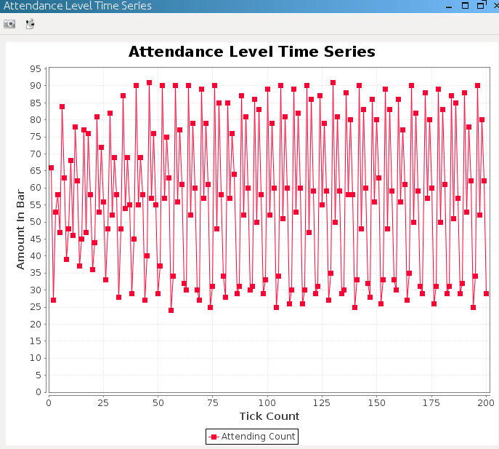
2 | 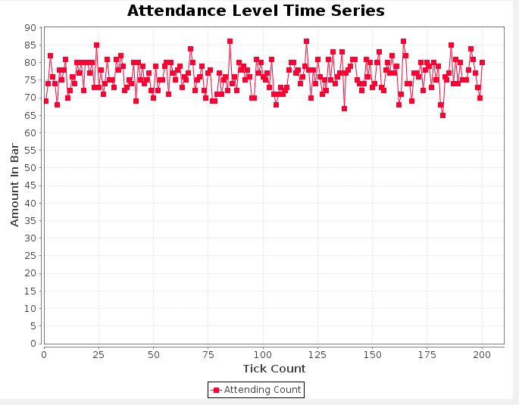
3 | 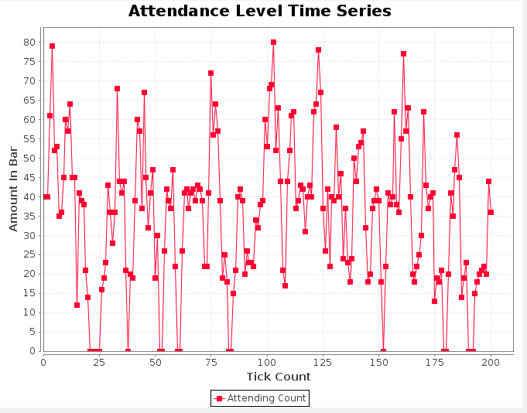
4 | 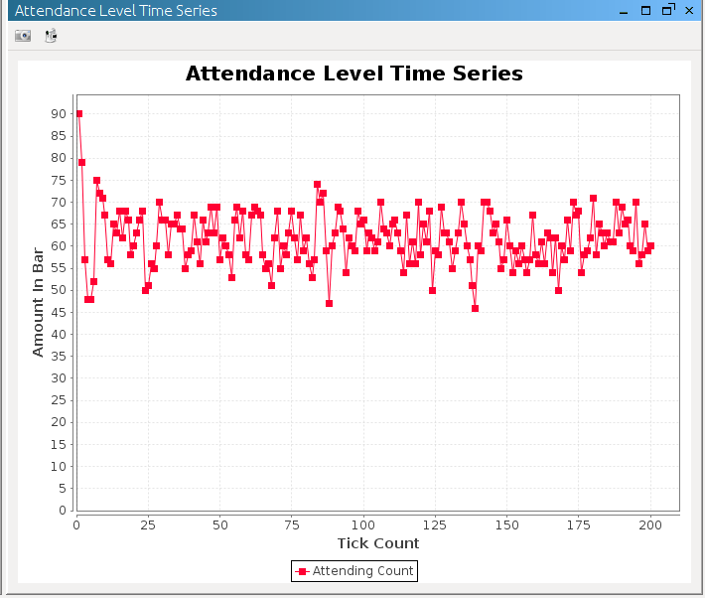
5 | 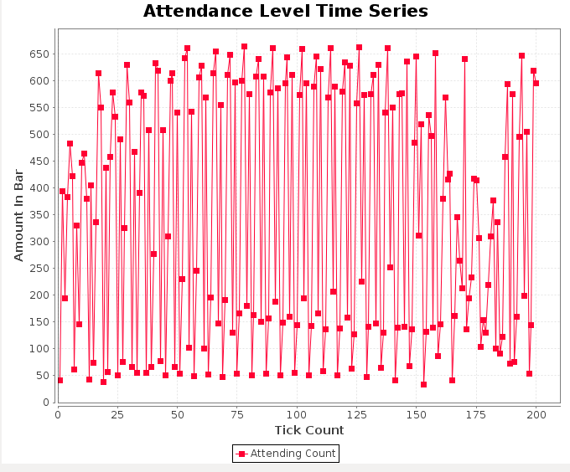
6 | 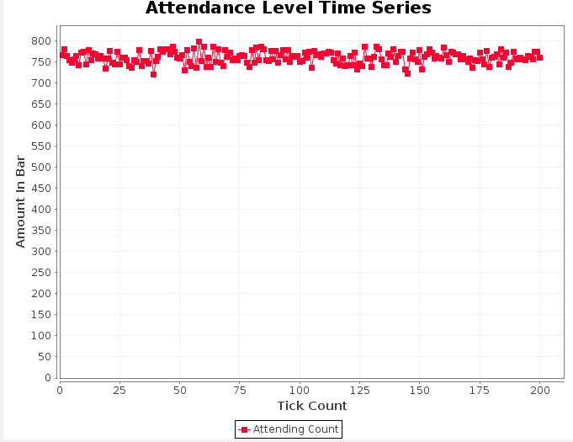
7 | 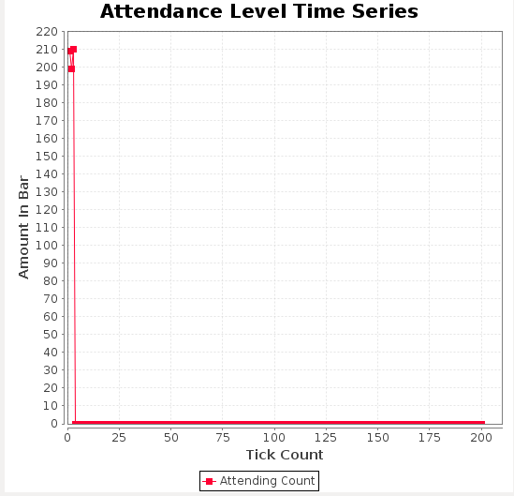
8 | 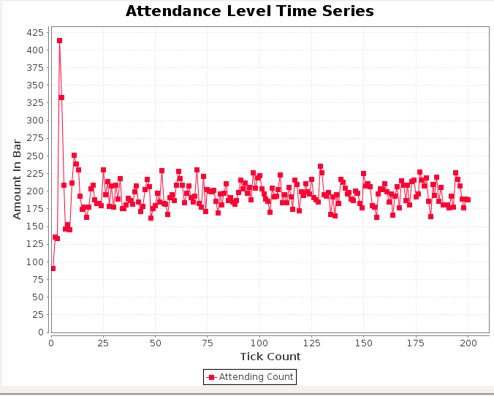
9 | 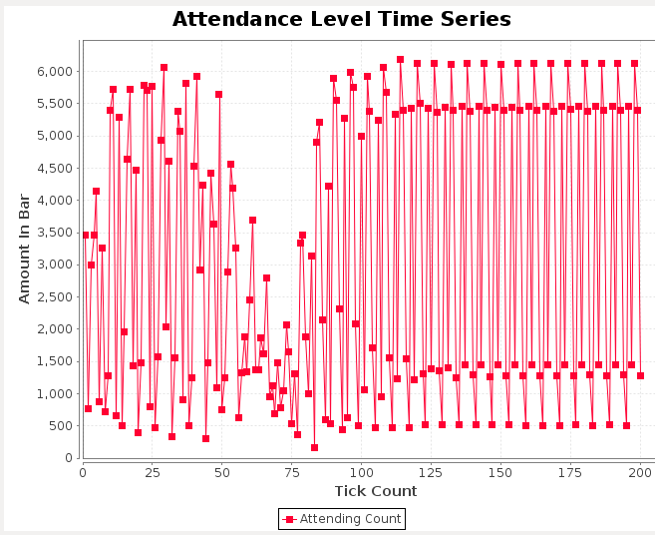
10 | 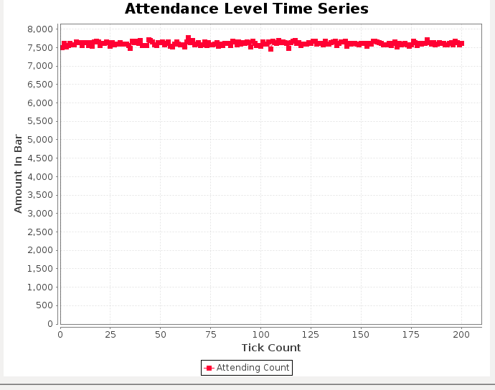
11 | 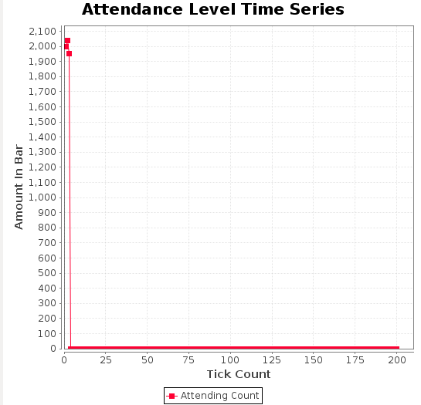
12 | 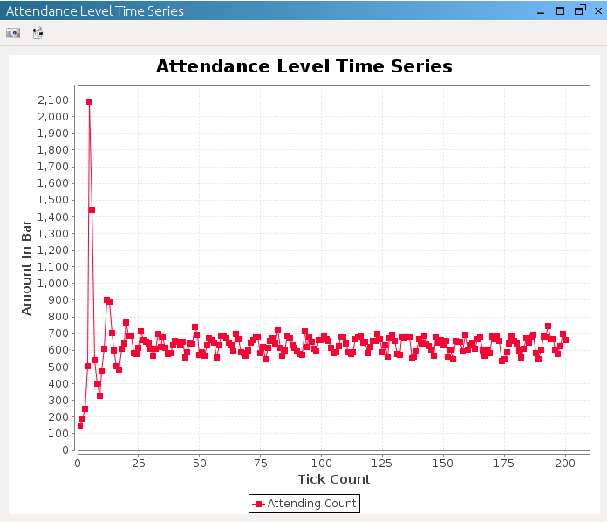
13 | 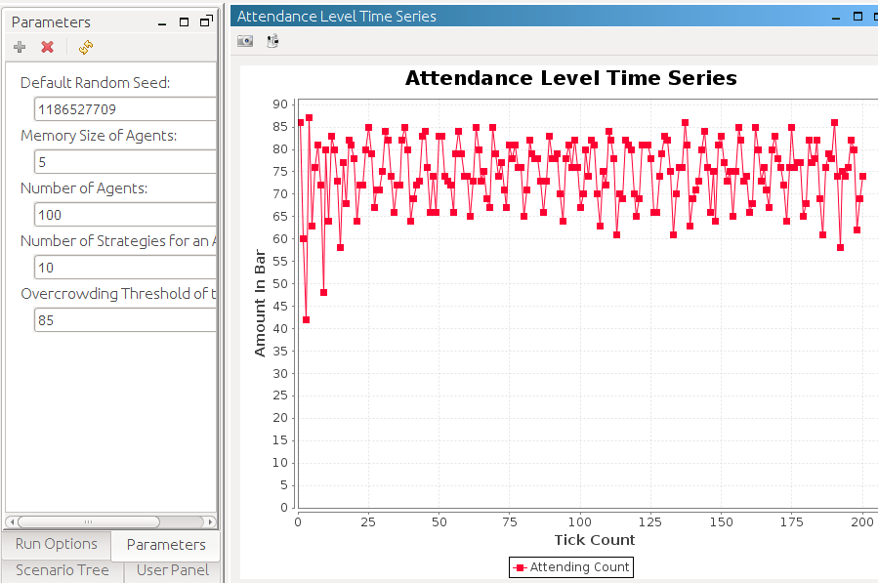
14 | 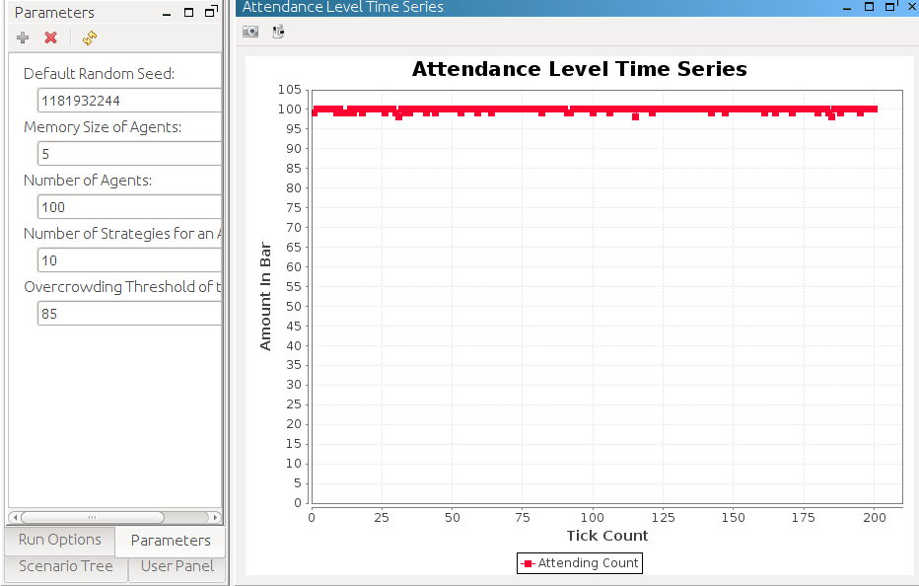
15 | 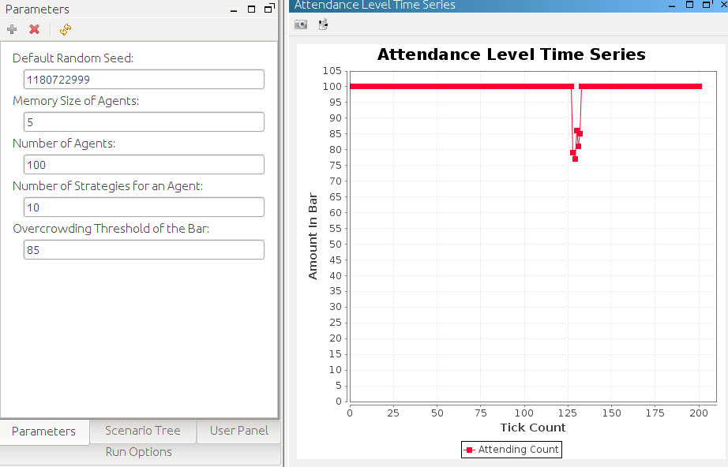
16 | 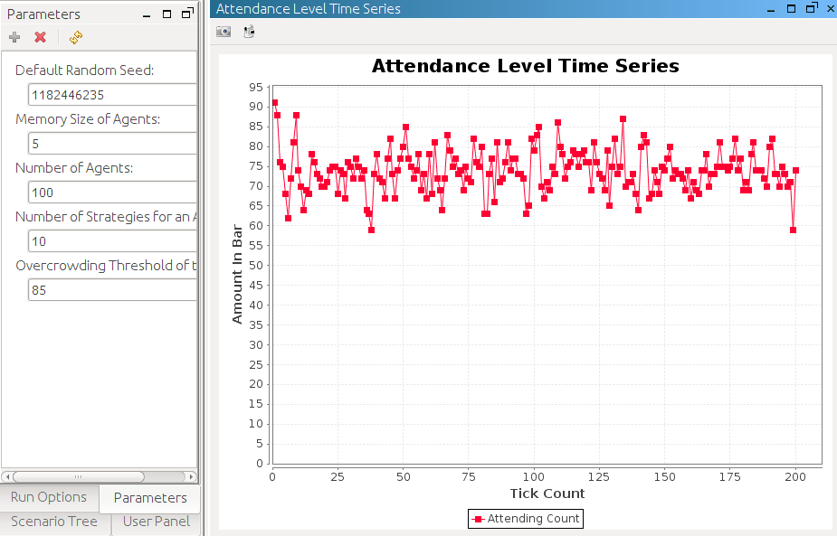
17 | 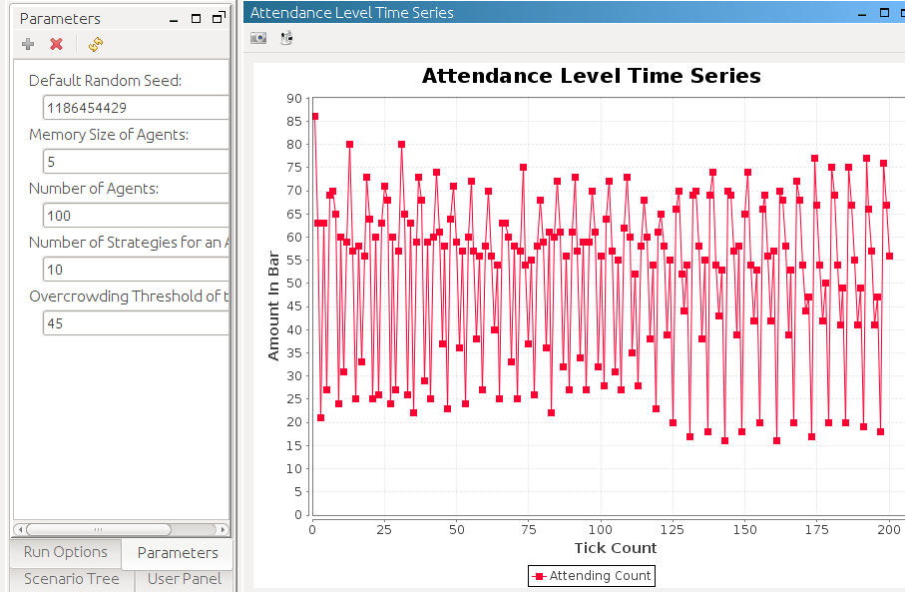
18 | 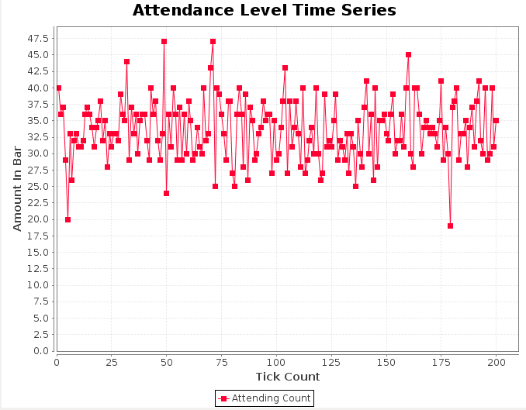
19 | 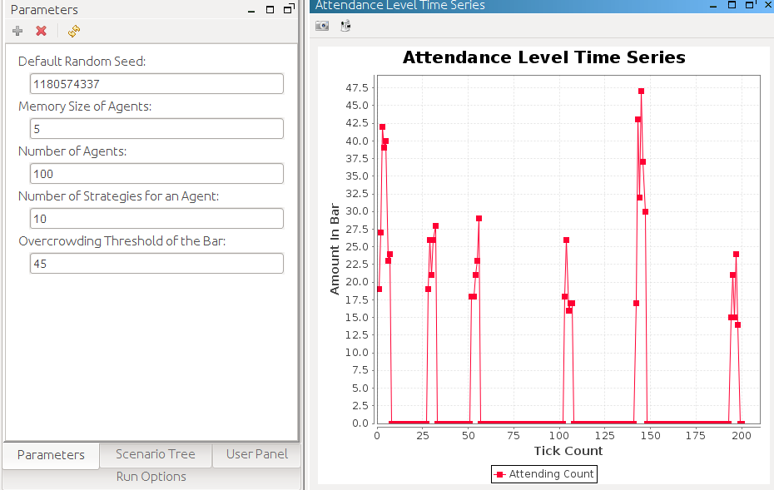
20 | 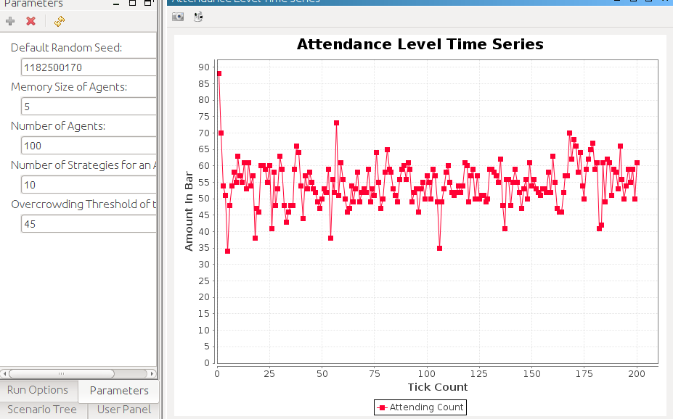
21 | 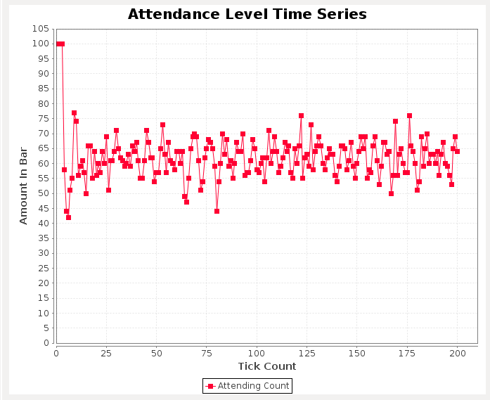

Code
SimpleStrategy.java: //contains all new Strategies
package elfarol;

import java.util.*;
import static elfarol.ParameterWrapper.*;

//Also contains the new smart strategy
public class SimpleStrategy
{

//predicts based off the average previous weeks attendance
public double prediction()
{
Random r = new Random();
int mem = getMemorySize();
int total = 0;
int count = 0;
double mean;
for(int i = 0; i<mem; i++)
{
total += r.nextInt(100)+1;
count++;
}
mean = (double)total/count;
//System.out.println(mean);
return mean;
}

//predicts based off a single random previous weeks attendance
public int predictionTwo()
{
Random r = new Random();
int randWeek = r.nextInt(getMemorySize());
int pastAttend = History.getInstance().getAttendance(randWeek);
return pastAttend;
}

//creates a double, based off history, that will be used to increase or decrease
//the probability of a randomly generated number
//to be close to the probability threshold.
public double weAreSmart()
{

int mem = getMemorySize();
double pastAttend;
int total = 0;

for(int i = 1; i<mem; i++)
{
total += History.getInstance().getAttendance(i);
}
pastAttend = (double)total/getMemorySize();
return pastAttend/getOvercrowdingThreshold();
}
}

Agent2 //contains all new agent strategy pickers
package elfarol;

import static elfarol.ParameterWrapper.*;

import java.util.ArrayList;
import java.util.List;
import java.util.Random;

import elfarol.strategies.AStrategy;
import elfarol.strategies.RandomStrategy;

//Agent containing all three new strategies
public class Agent2
{
public Agent2(){}

private boolean attend = false;

//Simple Strategy 1
public boolean strategyPicker()
{
SimpleStrategy strategy = new SimpleStrategy();
double predict = strategy.prediction();
attend = false;
if(predict < (double)getOvercrowdingThreshold())
{
attend = true;
}

return attend;

}

//Simple Strategy 2
public boolean strategyPickerTwo()
{
SimpleStrategy strategy = new SimpleStrategy();

int predict = strategy.predictionTwo();
attend = false;
if(predict < getOvercrowdingThreshold())
{
attend = true;
}
return attend;
}

//Smart strategy
public boolean strategySmart()
{
SimpleStrategy strategy = new SimpleStrategy();
Random r = new Random();
attend = false;
int randomAttend = r.nextInt(getOvercrowdingThreshold()*2);
double isGoing = randomAttend*strategy.weAreSmart();
if(isGoing< getOvercrowdingThreshold())
attend = true;
return attend;
}

public boolean isAttending() {
return attend;
}
/*
public boolean strategyPickerTwo()
{

}
*/
}

Edited Util.java:
package elfarol;

import java.util.ArrayList;
import java.util.Collections;
import java.util.List;

import repast.simphony.engine.environment.RunState;

/**
* Simple wrapper class for common utility methods for the <i>El Farol</i>
* simulation.
*
* @author Richard O. Legendi (richard.legendi)
* @since 2.0-beta, 2011
* @version $Id: Utils.java 1123 2011-08-22 19:40:45Z richard.legendi@gmail.com $
*/
public class Utils {

/**
* Returns the list of agents containing the {@link Agent} instances
* associated to the master (<i>root</i>) context.
*
* @return an <i>unmodifiable collection</i> containing all the
* {@link Agent} instances
*/

public static List<Agent2> getAgentList() {
@SuppressWarnings("unchecked")
final Iterable<Agent2> agents = RunState.getInstance()
.getMasterContext().getObjects(Agent2.class);

final ArrayList<Agent2> ret = new ArrayList<Agent2>();

for (final Agent2 agent : agents) {
ret.add(agent);
}

return Collections.unmodifiableList(ret);
}

/**
* Returns the current attendance level of the bar.
*
* @return the number of agents whose attendance flag is <code>true</code>;
* <code>0 <= return value <= number of agents</code>
*/
public static int getAttendance() {
int ret = 0;

for(final Agent2 act : getAgentList())
{
if(act.isAttending())
{
ret++;
}
}
return ret;
}

}

Edited ElFarolContextBuilder.java
package elfarol;

import static elfarol.ParameterWrapper.*;
import repast.simphony.context.Context;
import repast.simphony.context.DefaultContext;
import repast.simphony.dataLoader.ContextBuilder;
import repast.simphony.engine.schedule.ScheduledMethod;

/**
* The context builder for the <i>El Farol</i> simulation.
*
* @author Richard O. Legendi (richard.legendi)
* @since 2.0-beta, 2011
* @version $Id: ElFarolContextBuilder.java 514 2011-07-08 14:50:51Z
* richard.legendi@gmail.com $
*/
public class ElFarolContextBuilder extends DefaultContext<Object> implements
ContextBuilder<Agent2> {

// ========================================================================
// === Super Interface ====================================================

/*
* (non-Javadoc)
*
* @see
* repast.simphony.dataLoader.ContextBuilder#build(repast.simphony.context
* .Context)
*/
public Context<Agent2> build(final Context<Agent2> context) {
ParameterWrapper.reinit();
History.getInstance().init();

for (int i = 0; i < getAgentsNumber(); ++i) {
final Agent2 agent = new Agent2();
context.add(agent);
}

return context;
}

// ========================================================================
// === Schedule ===========================================================

/**
* Main schedule of the simulation containing the following phases:
*
* <ol>
* <li><b>First</b>, all agents determine if their attend to the bar based
* on their knowledge (<i>strategies</i>) and the prediction</li>
* <li><b>Then</b> we update the global history</li>
* <li><b>At the end of the turn</b> when the new attendance level is known,
* all of the agents update their best strategy</li>
* </ol>
*/

@ScheduledMethod(start = 1, interval = 1)
public void schedule() {

for (final Agent2 act : Utils.getAgentList()) {
act.strategySmart();
}

History.getInstance().updateHistory();

}

// ========================================================================
// === Observer Methods ===================================================

/**
* Returns the current attendance level of the bar to display in a simple
* time series chart on the Repast GUI.
*
* @return the current attendance level of the bar
*/
public int attendance() {
return Utils.getAttendance();
}

}

Lab Result Analysis

For the first strategy we implemented, we had the simple strategy get a prediction based off the average previous weeks attendance. The way we accomplished this was by randomly generating the number of people from one to 100 for a previous week's attendance for a number of weeks equal to the memory size. The average would be taken of those number of weeks and that would be the Agent's prediction for the current week. Based off this information the Agent would then decide whether or not to go to the bar.
The second strategy we created for deciding to go to the bar was choose a random week within the memory size and get the information for the number of people in attendance that week. The Agent predicted the number of people in attendance this week would be the same as the number of people in attendance for the selected random week. Based off the number, the agent would then decide whether or not to go to the bar.
Finally, the smart strategy we implemented creates a double based off the history that either increases or decreases the probability of a randomly generated number to be close to the probability threshold. The Agent then generates a random integer from zero to the overcrowding threshold and multiplies that int by two. If the random number multiplied by the smart strategy is less than the overcrowding threshold, the Agent will go to the bar.
The first trend we notice in the graph is all the graphs for the original regression strategy tend to fluctuate around the over crowding threshold. A second trend we notice is when the number of agents increases to 1,000 or 10,000 the number of agents attending is far over the overcrowding threshold.
The biggest take away from this assignment was understanding how to implement a probability. The way different strategies combined in Graph 21 was a valuable demonstration of how people use different strategies and try to adjust to find equilibrium. Challenges we faced were figuring out how to make a probability calculation for the smart strategy. The other problem was in creating Graph 21 to show how people use different strategies, which affects the attendance at the bar.

